**Python Prebuild Design Patterns**

<https://docs.google.com/document/d/1lCD36oO8p5Oc8CHqitR-pJpGEx1oHd7K2LYEDPdg6xs/edit?tab=t.0>

<https://github.com/Deepanshu-TTN/bootcamp-git/tree/master/week-4/Prebult%20Design%20Patterns>

Check github for updated code with docstrings and better coding style

Write an object oriented code to implement Prime number class.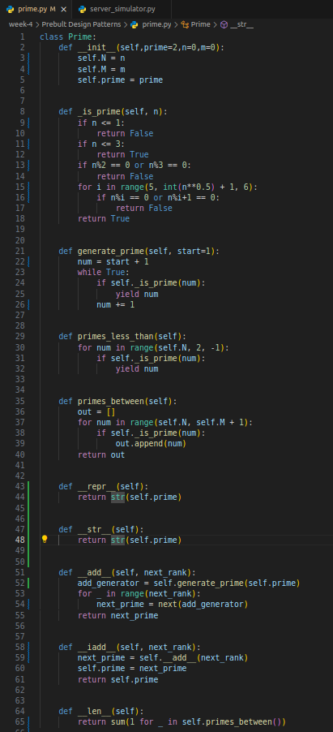

The class can be initialized by N, M and prime for the functionalities mentioned below

Implement a Prime class which should have following funcnatinality:

- Ability to test if a number is prime or not

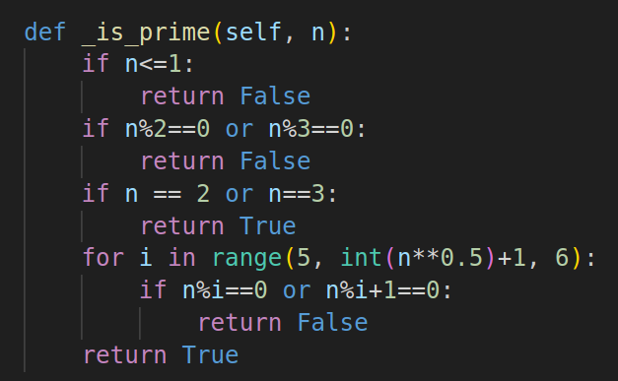

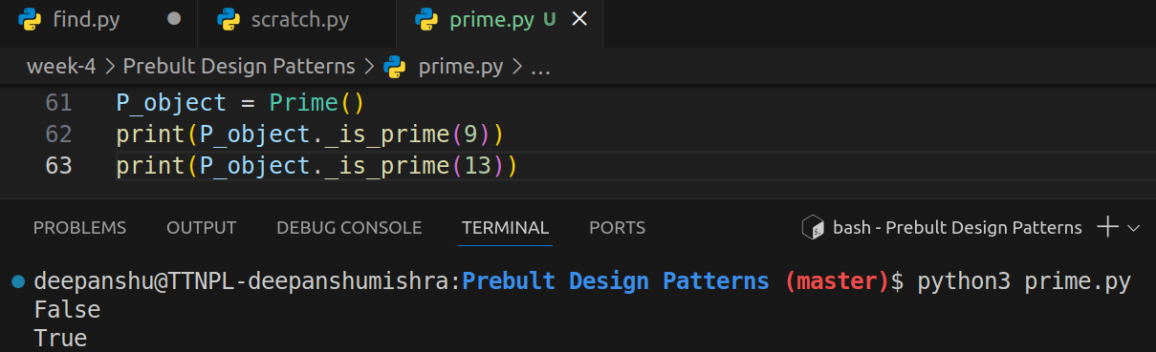

- Generate prime numbers

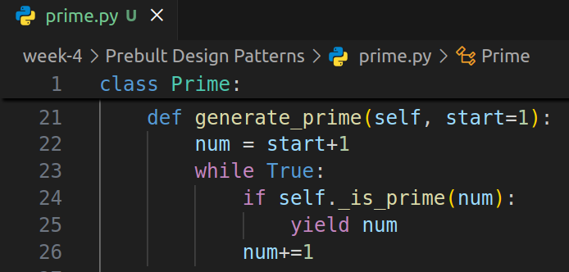

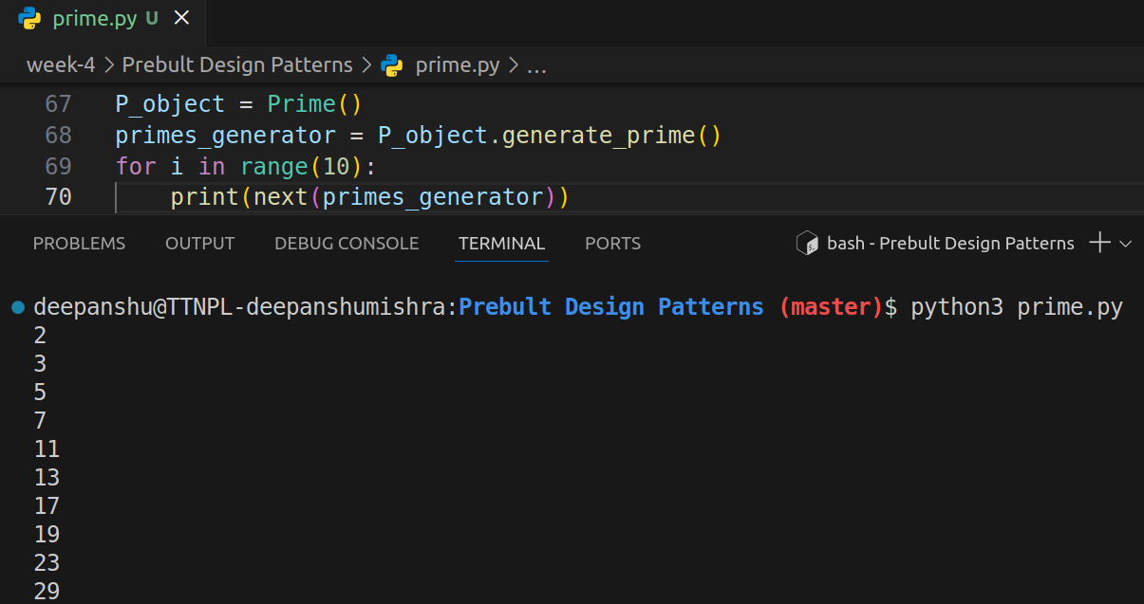

- Generate prime numbers greater than a number N

Initialized the P_object with n=5 and passed it to generate_prime function to generate 10 prime numbers greater than 5

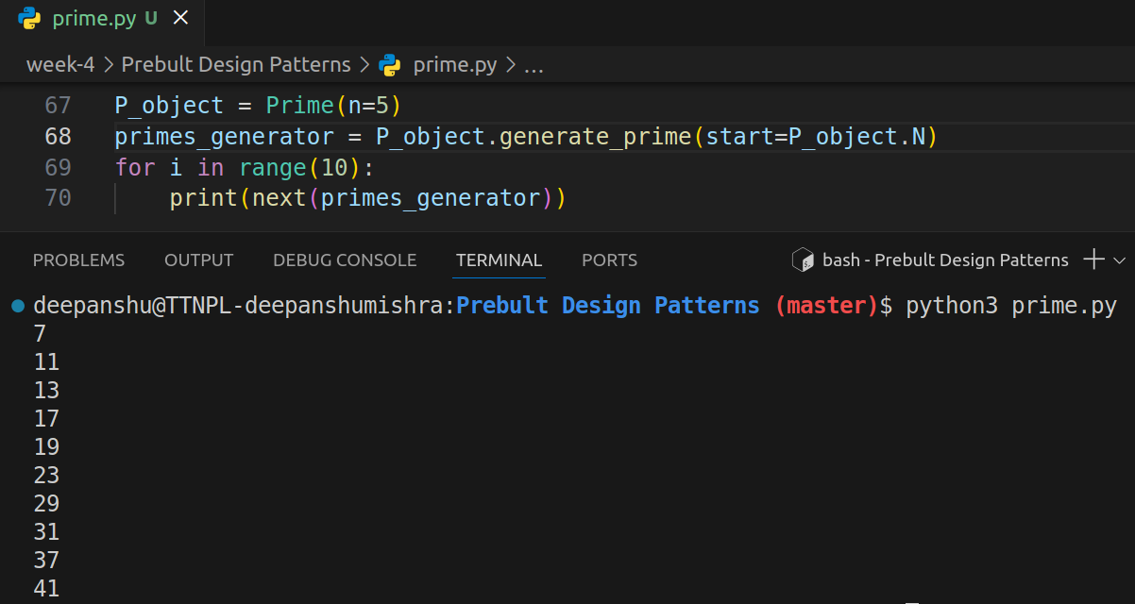

- Generate prime numbers less than a number N

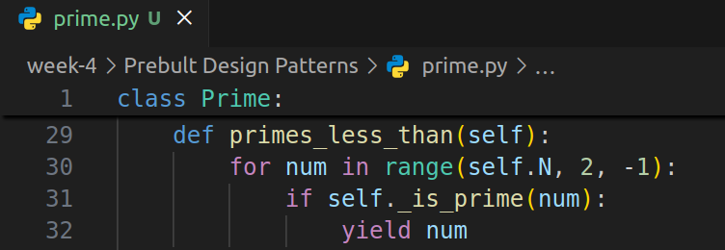

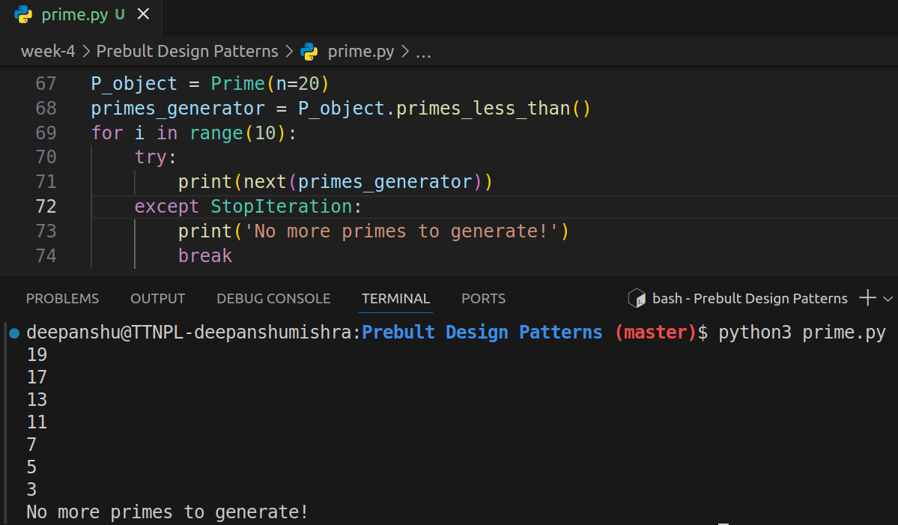

- Generate all prime numbers between N, to M

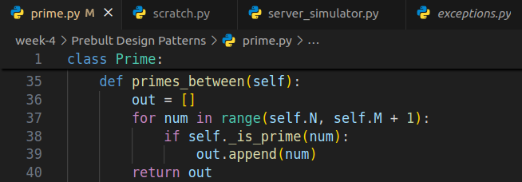

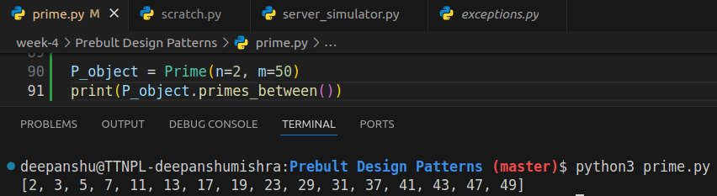

- implement __len__() to tell number of primes between N and M where N < M

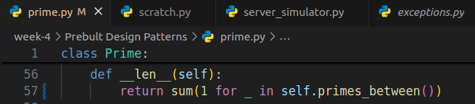

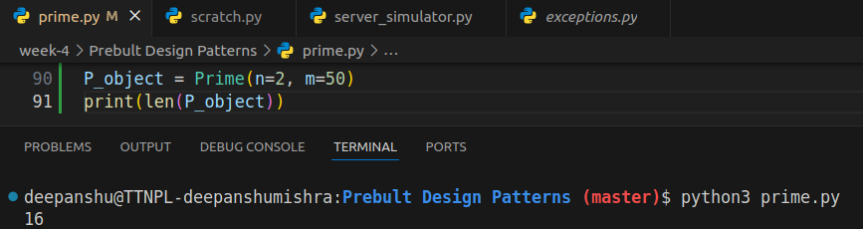

- overload +, += operators to nerate number prime number with respect to current prime nuber e.g.

>> p = Prime(3)

>> p + 1

5

>> p + 2

7

>> p += 3

>> p

Prime(11)

implement `__repr__()` and `__str__() methods

